**JUNAID GIRKAR**

**60004190057**

**TE COMPS A4**

EXPERIMENT - 9

Here we will discuss all the CRUD operations on the SQLite3 database using Python. CRUD contains four major operations –

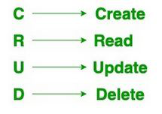

Code:

| # Import module import sqlite3   # Connecting to sqlite conn = sqlite3.connect('hello.db')   # Creating a cursor object using # the cursor() method mycursor = conn.cursor()  mycursor.execute("create table student (stud_id INT(6) PRIMARY KEY, name VARCHAR(20), marks INT);")  for x in mycursor:  print(x) mycursor.execute("alter table student add column division VARCHAR(1);") print('(attribute, type, null, key, default, extra)')  for x in mycursor:  print(x) mycursor.execute("insert into student (stud_id, name, marks, division) values (1,'Harry',98,'A');") mycursor.execute("insert into student (stud_id, name, marks, division) values (2,'James',37,'B');") mycursor.execute("insert into student (stud_id, name, marks, division) values (3,'Draco',92,'C');") conn.commit() mycursor.execute("select * from student;") myresult = mycursor.fetchall() for x in myresult:  print(f'{x[0]}\t{x[1]}\t{x[2]}\t{x[3]}') mycursor.execute("update student set marks = 99 where name = 'Harry';") conn.commit() print(mycursor.rowcount, "record(s) affected") mycursor.execute("select * from student;") myresult = mycursor.fetchall() for x in myresult:  print(f'{x[0]}\t{x[1]}\t{x[2]}\t{x[3]}') mycursor.execute("delete from student where division = 'B';") conn.commit() print(mycursor.rowcount, "record(s) deleted") mycursor.execute("select * from student;") myresult = mycursor.fetchall() for x in myresult:  print(f'{x[0]}\t{x[1]}\t{x[2]}\t{x[3]}') mycursor.execute("drop table if exists student;") for x in mycursor:  print(x) |
| --- |

Output:

| (attribute, type, null, key, default, extra) 1 Harry 98 A 2 James 37 B 3 Draco 92 C 1 record(s) affected 1 Harry 99 A 2 James 37 B 3 Draco 92 C 1 record(s) deleted 1 Harry 99 A 3 Draco 92 C |
| --- |

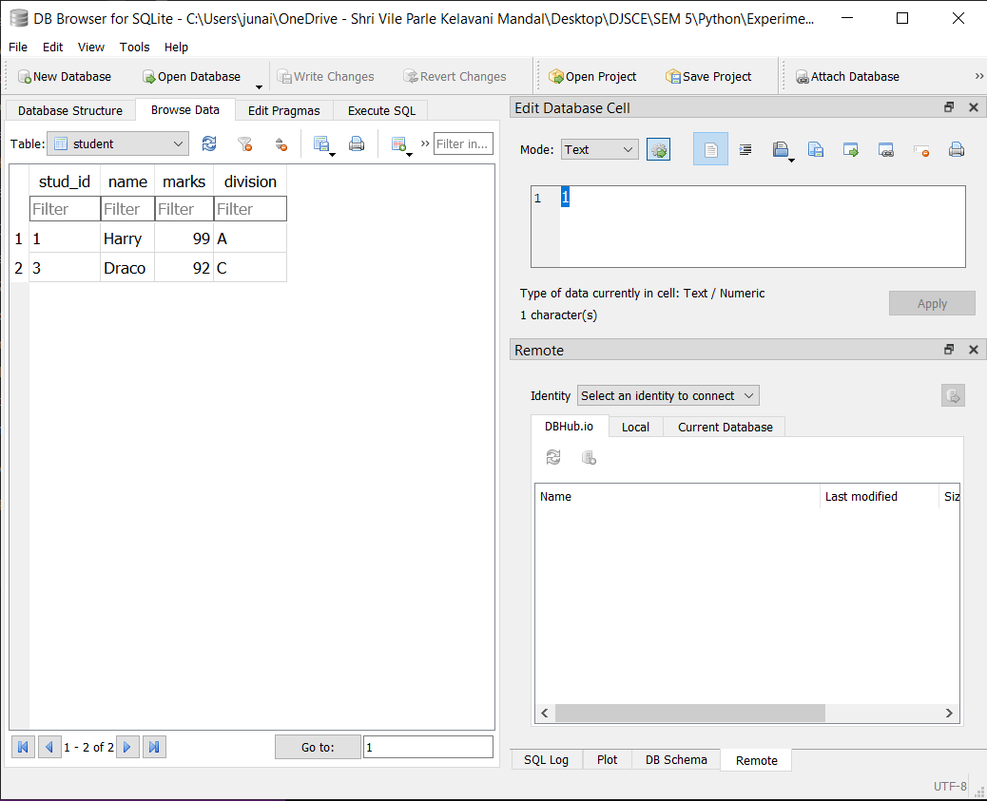

**Conclusion**:

We learnt about executing SQL commands in python and implemented a python program implementing CRUD functionality.